**Economical Duck Manual**

**By Team 404**

Table of Contents

**Opening the Device** 3

Using the device 5

**Payload Files** 6

**Basic Economical Duck Script Manual** 7

**Advanced Economical Duck Script Manual** 10

Manual Packet Generation 11

**Configuration** 13

**Key Index** 15

**Modifiers** 15

# **Opening the Device**

If you plan to put payload on the device via the SD card, you must open the device to get access to the SD card.

To open the device, first remove all the cables from the device. Then, pop off the white lid from the red body of the device. The white section has a lip which can be used to pull it off.

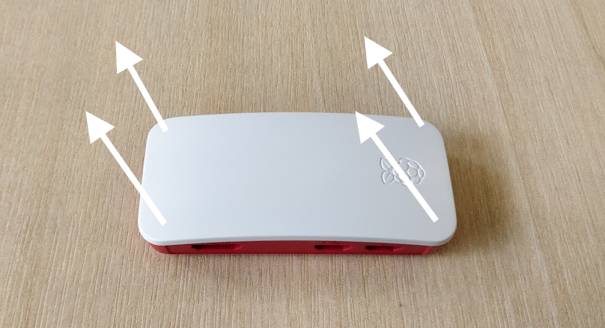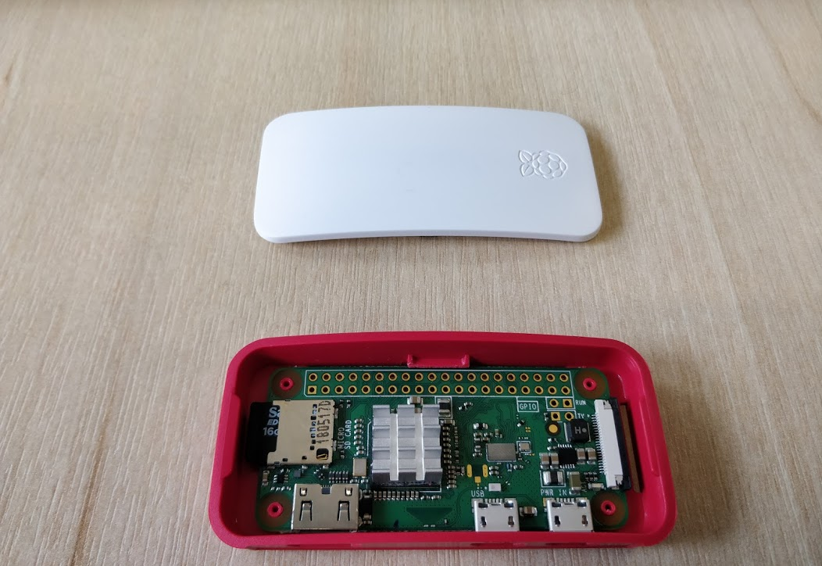

Next, remove the device from the body of the case, using the hole in the bottom to pop it out.

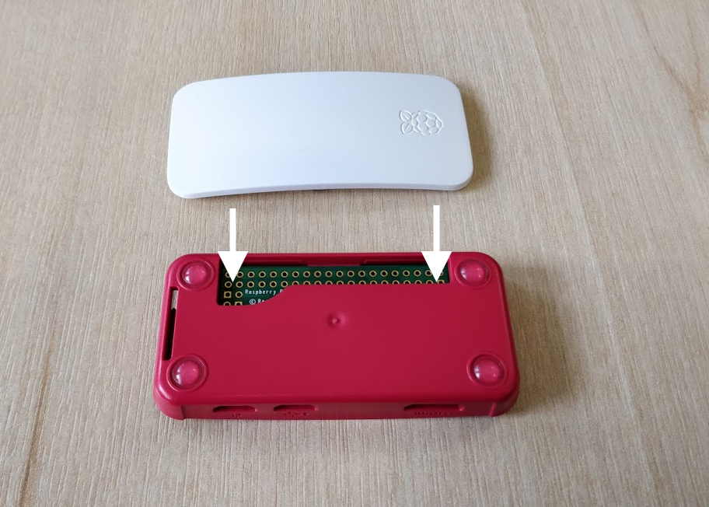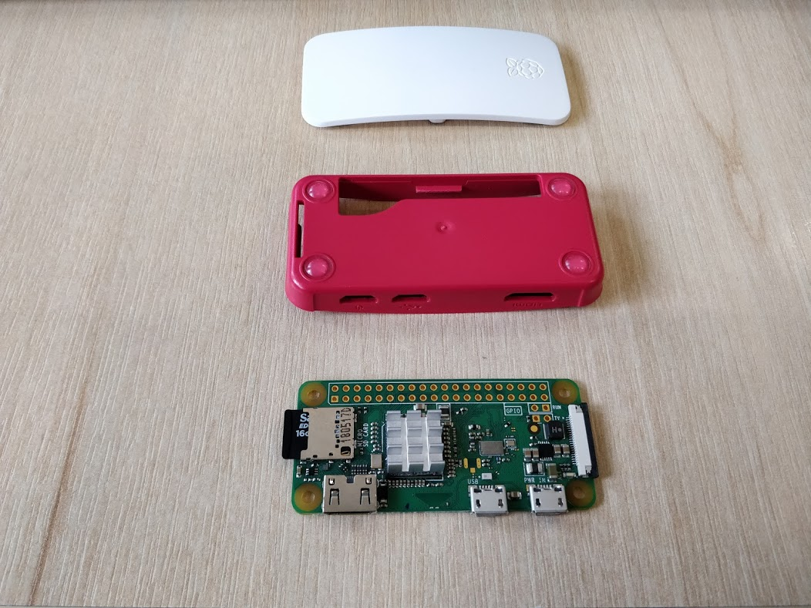

Next, remove the micro SD card from the device

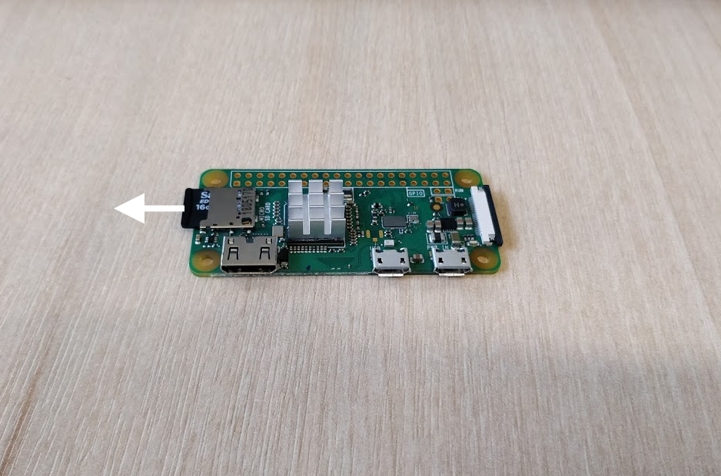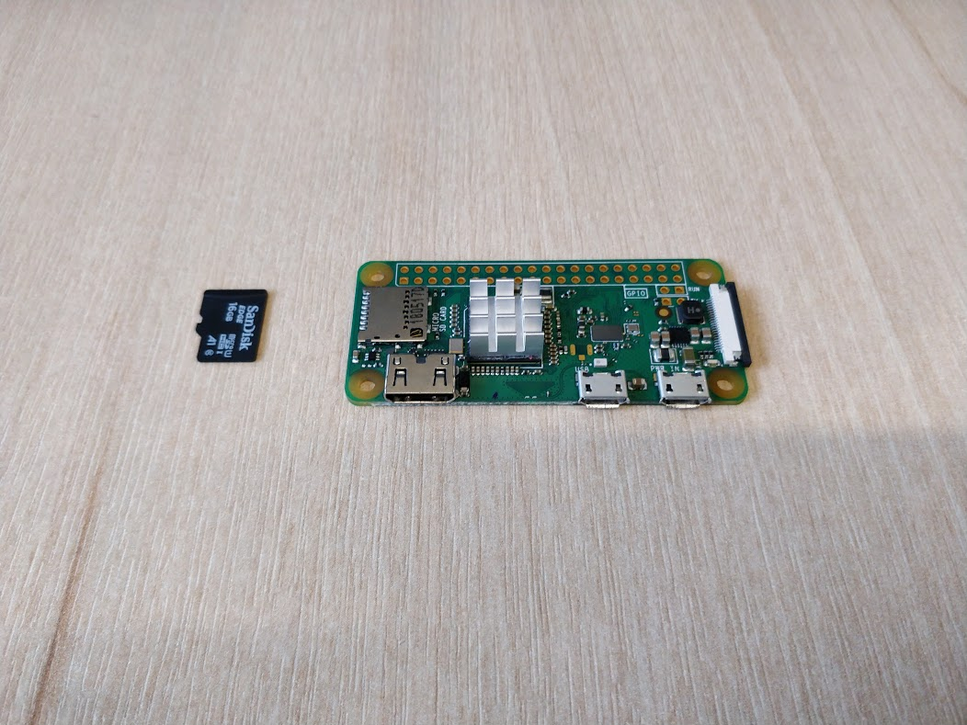

Then insert the device into the micro sd card reader.

If you do not have a micro sd card reader, you will need to use an adapter to convert it to a SD card.

To do this, insert the micro SD card into the SD card adapter

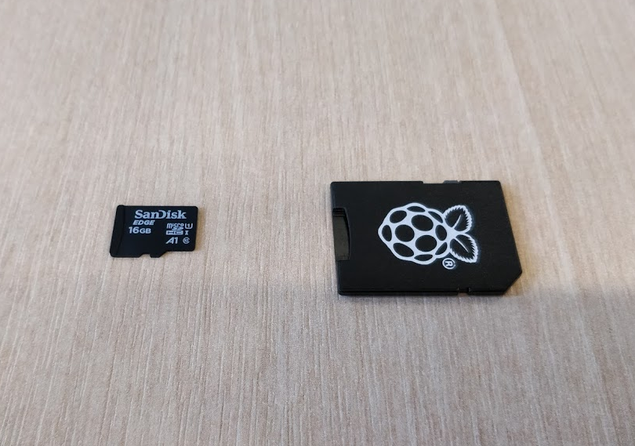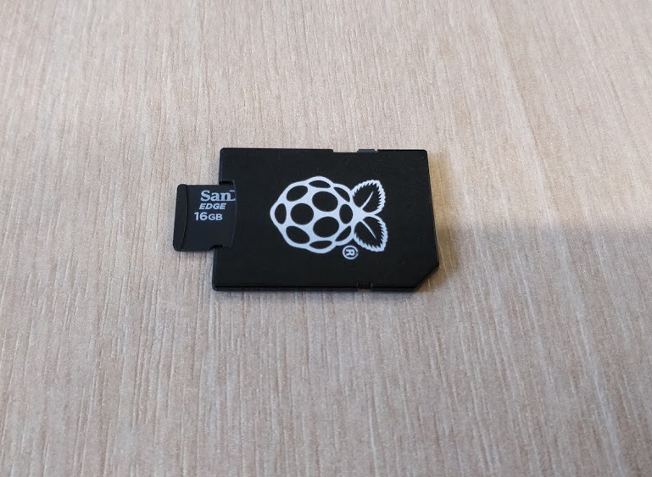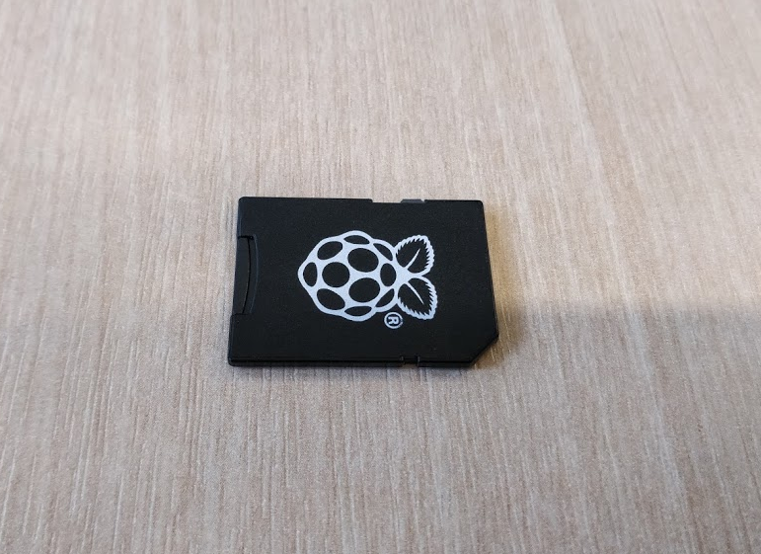

Then, insert the SD card adapter into the SD card reader on your computer.

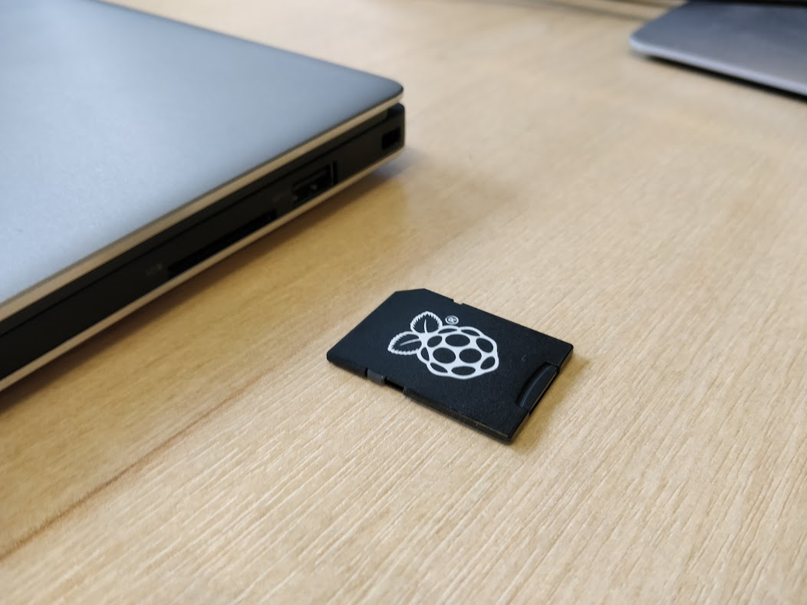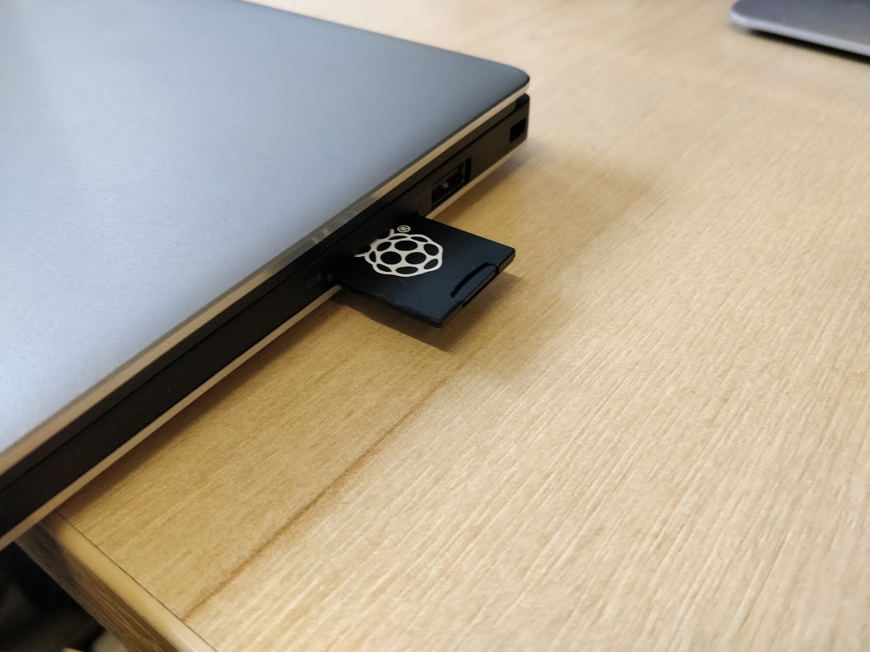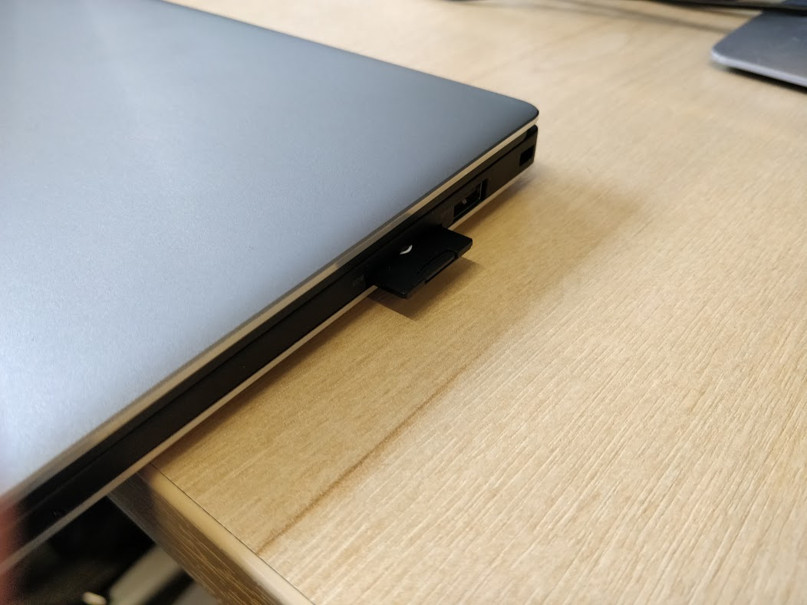

If you do not have an SD card reader you will need to access the device over SSH.

NOTE: If a window appears as seen below, click ‘Continue without scanning’.

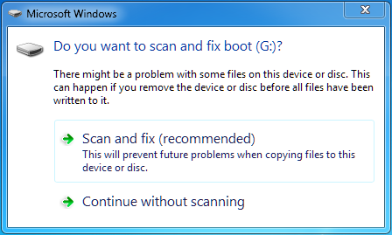

After this, it is possible to begin work on creating a payload file and loading it onto the Economical Duck. To do this, see ‘**Payload Files**’ below.

When reassembling he device, make sure the holes for the connectors on the case match up with the connectors on the device itself (see ‘Using the device’ below).

# **Payload Files**

Payload file scan be added to the device in two different ways:

**SD Card Access**

**For a Windows PC**, remove the SD card from the Economical Duck and insert it into an SD card reader to mount. Once mounted, create the appropriate payload file with the corresponding name as seen below (see ‘Payload file names’) into the root directory of the ‘boot’ drive within the SD card.

NOTE: Make sure you copy your payload file to this directory, as they are removed from this directory on boot and moved to the ‘/usr/ecoduck’ directory. Payloads added through this method additionally have a limit of 20MB.

**For a Linux PC**, remove the SD card from the Economical Duck and insert it into an SD card reader to mount. Once mounted, create the appropriate payload file with the corresponding name as seen above into the ‘/usr/ecoduck/’ directory.

**Remote Access**

**For any OS**, it is possible to SSH into the Economical Duck through any SSH client and create the appropriate payload file with the corresponding name as seen above into the root partition under the ‘/usr/ecoduck/’ directory.

**Payload file names**

The payload files must be named in a specific manner so the device knows what operating system the payload is designed for.

For Windows machines, the ‘**win.txt**’ file is used for Basic payloads, and the ‘**win.py**’ file is used for advanced payloads.

For Linux machines, the ‘**linux.txt**’ file is used for Basic payloads, and the ‘**linux.py**’ file is used for advanced payloads.

Advanced users can override the operating system payload selection and the default payload can be overwritten in the configuration file described below.

# **Basic Economical Duck Script Manual**

By default the device is configured to read the basic “Economical Duck Script”. This is designed for beginners and is what we expect the majority of users to use. If you wish to code your payloads in python, see the configuration options and the “Advanced Economical Duck Script Manual” section.

To see how to put payloads onto the device, see the “Opening the Device” and “Payload files” sections.

It should be noted that when the payload has finished executing, the caps lock LED with flash on the target pc.

**Commands**

Basic Economical Duck Script (EDS) functions using five different commands.

**NOTE: All commands are case sensitive, all arguments after a command are not.**

E.g.  
COMMAND aRgUmEnT

See below for each command and their respective functionality:

**CMT**

This is a comment command and thus any text after this command is ignored by the Economical Duck as long as it is on the same line.

For example, the following line would have no operation:

CMT This line will be ignored

**DELAY X**

Tells the Economical Duck to delay execution of the rest of the payload by X number of seconds.

For example, the below would wait half a second before continuing with execution:

DELAY 0.5

**NOTE: Using delays to allow the computer to catch up is very important. The device can type faster than the operating system can keep up with. Use them liberally wherever the computer needs to open or run a program.**

**PRESS <insert key combinations here>**

This command handles singular or multiple simultaneous keypress combinations, up to a maximum of 6 unique keys. It should be noted that modifiers do not count towards this limit.

Modifiers include the following keys:

|  |  |
| --- | --- |
| Left Control | LCTRL |
| Left Shift | LSHIFT |
| Left Alt | LALT |
| Left GUI* | LGUI |
| Right Control | RCTRL |
| Right Shift | RSHIFT |
| Right Alt | RALT |
| Right GUI* | RGUI |

* - This key depends on the type of keyboard used, other terms for this key include ‘Windows Key’, ‘Super Key’, ‘Meta Key’, or for a Mac Keyboard ‘cmd’.

The ‘+’ symbol is used between each key specified when declaring a combination.

**NOTE: If the user wants to enter the plus symbol as its literal value, then they must say “plus” rather than “+”.**

A full list of the acceptable keys can be found in the Key Index section of this manual.

For example, to perform a CTRL ALT DELETE combination correctly would require the following:

PRESS LCTRL+LALT+DELETE

PRESS LGUI+r

**TYPE <insert string of characters here>**

This command is used to type long strings of characters. Everything specified after ‘TYPE ’ will be sent to the target machine.

For example, the following input:

TYPE This will be typed exactly as specified here.

Will give the following output on the target PC:

This will be typed exactly as specified here.

**NOTE: if the user entered ‘delete’ or ‘LCTRL’, then these would not be recognised as their keyboard buttons. They would be interpreted as the literal text.**

**REPEAT X <insert commands here> END**

This command is used to repeat all commands within it X number of times.

All REPEAT commands must finish with an END to declare the end of a REPEAT, for example:

REPEAT 3  
TYPE Hello  
END

Will give the following output:

HelloHelloHello

This command also supports nesting, for example:

REPEAT 2  
TYPE First Repeat  
PRESS Enter  
REPEAT 3  
TYPE Second Repeat  
PRESS Enter  
END  
END

Will give the following output:

First Repeat  
Second Repeat  
Second Repeat  
Second Repeat  
First Repeat  
Second Repeat  
Second Repeat  
Second Repeat

# **Using the device**

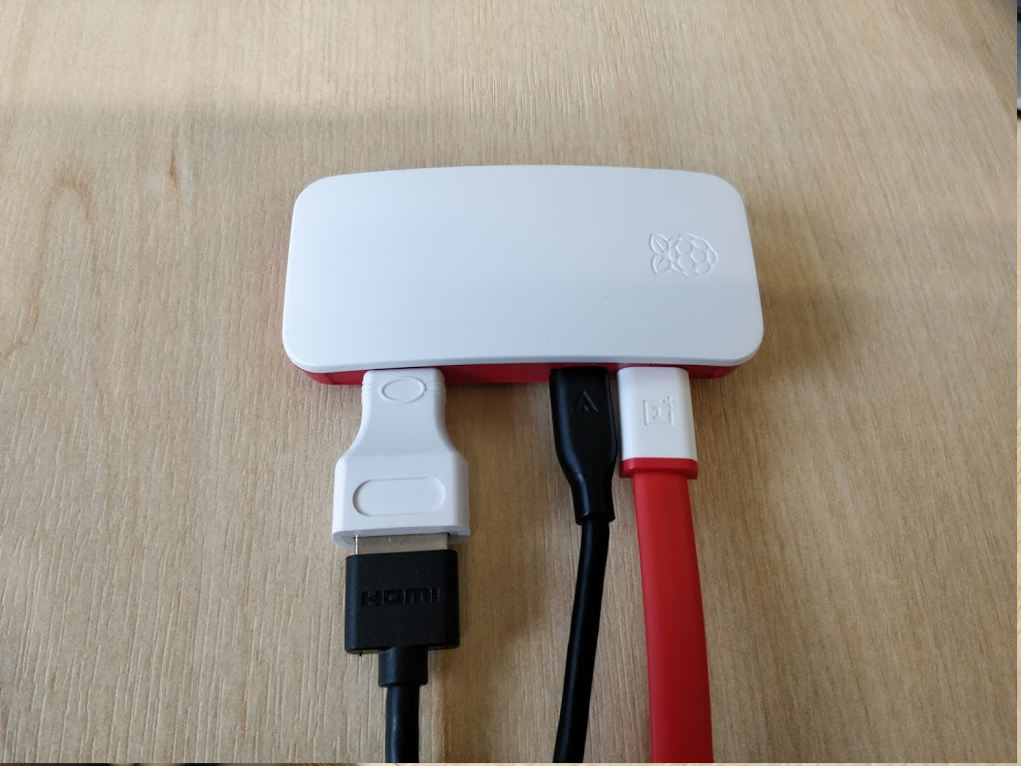

Once a payload has been moved on the micro sd card of the device, it must be reassembled by going through the disassembly instructions in reverse.

The micro hdmi cable on the far left can be connected to a monitor to display debug information. The debug screen can be escaped by pressing Ctrl+Alt+f2 to get console access on the physical device.

The red cable inserted into the right micro-usb port should be connected to a power source to power the device.

The black cable in the left micro-usb port should be connected to the target pc.

The device will take approximately 30 seconds to boot. Afterwards it will immediately run the payload. Once booted, payloads will execute after being plugged into a computer for 5 seconds. This is to allow the device to detect the operating system and select the correct mode.

# **Advanced Economical Duck Script Manual**

In order to use the device in advanced mode, it must be enabled in the configuration file. For more information about this see the “Configuration” section.

The purpose of these functions and how they can be used can be seen below;

**press() function:**

This function takes in a string which will contain the keypresses and modifiers that the user wants to run on the target pc. It will automatically send and run these on the target machine when called.

For example, if the user wanted to press CTRL, ALT, DELETE on the targets keyboard, then the string that should be passed to the function is “LCTRL+LALT+delete”.

The “+” character in this function is used as a separating character to separate each keypress. If the user wants to enter the plus symbol as its literal value, then they must say “plus” rather than “+”.

For each part of the string that was separated using the “+” symbol, the function would run through a list of modifiers to find if any of the entered parameters matched a modifier. If they do match then the modifier is toggled to true so that the HID packet sent knows that the specified modifier must be set. Using the example above, the LCTRL and LALT modifiers would be toggle to true.

At the end of this function, the createHIDpacket function is called, passing in the keypresses and modifiers the user has specified. After the HID packet is created, the sendHIDpacket is called to send the packet to the target.

**type()**

The type function will run attempt to type the string as given as closely as possible on the target pc. This includes pressing the shift key for capital letters or symbols. For example if the user wanted to run the command ‘echo “Hello World!”’ on the target computer then they would do the following;

type(“echo \”Hello World!\””)

NOTE: if the user entered ‘delete’ or ‘LCTRL’, then these would not be recognised as their keyboard buttons. They would be interpreted as strings.

**get_ip()**

This function will return the ip address of the target pc over the networking adapter gadget configured on the economical duck. This function will raise an error if the gadget is in simple mode as it does not support networking. If the IP address cannot be found, it will return “n/a”.

**is_network_connected()**

This function will determine if the networking has been configured on the target PC. It will return true if the device can ping the target pc, and false if it cannot.

**wait_for_network_state(state, timeout=0)**

This function will wait to the networking state is equal to the one passed to the function. By default it will wait forever, however this can be set to timeout after a number of seconds. If the function times out it will return false.

**is_hid_connected(timeout=2)**

This function will determine if the keyboard has been configured on the target PC. It will return true if the device can receive a response from the target PC.

**wait_for_keyboard_state(state, timeout=0)**

The function will wait till the keyboard state is equal to the one passed to the function. By default it will wait forever, however this can be set to timeout after a number of seconds. If the function times out it will return false.

## Manual Packet Generation

For very advanced users who wish to send very specific HID packets to the target PC, they can access the HID packet functions of the economical duck to send these. This is not recommended and should be avoided if possible.

If a user wishes to use these functions, they should look at the ecoduck.py source code in the “ecoduck-software” repository to understand how it works and what it expects.

**createHIDpacket(ScanCodes = [], modifiers = []) function:**

This function will take in a list of keypresses, and a list of modifiers that are to be set. A maximum of six keypresses can be passed in. The function will then form and return a HID packet.

The modifiers that can be set are:

1. Right GUI
2. Right Alt key
3. Right Shift key
4. Right CTRL key
5. Left GUI
6. Left Alt key
7. Left Shift key
8. Left CTRL key

The syntax for the createHIDpacket function is as follows:   
  
**createHIDpacket(KeyList,ModifierList)**  
**KeyList is a list of the keypresses to be included in one packet and ModifierList is a list of all the modifiers that are to be set.**

The syntax for these modifiers are:

1. RGUI
2. RALT
3. RSHIFT
4. RCTRL
5. LGUI
6. LALT
7. LSHIFT
8. LCTRL

(See Modifiers section below for more information)

Therefore, if a user wanted to create a HID packet for CTRL ALT DELETE it could be done as follows:

**Keypresses = [“delete”]**  
  
**Modifiers = [“LCTRL”, “LALT”]**  
  
**sendHIDpacket = (createHIDpacket(KeyList,ModifierList))**

The Function would then formulate the HID packets based on the scan codes for each keypress.

NOTE: This function will not send the HID packet to the target, it will only return the HID packet to the user. It is up to the user to send the HID packet using the sendHIDpacket function.  
   
**sendHIDpacket(HIDpacket)** **function**:

This function takes in a HID packet and will send it to the target device. The HID packet is created in binary and unless the user has used the createHIDpacket function to create it, then they will require an expertise on how the HID protocol works.

# **Configuration**

The configuration file for the Economical Duck can be found in the following location:

For Windows, insert the SD card of the Economical Duck into an SD card reader to mount onto the Windows machine. Once mounted, the ‘ecoduck.conf’ file can be located within the root of the ‘boot’ drive.

For Linux, insert the SD card of the Economical Duck into an SD card reader to mount onto the Linux machine. Once mounted, the ‘ecoduck.conf’ file can be located by navigating to ‘/boot/ecoduck.conf’.

The configuration file contains eight settings which can be modified:

**Toggle whether to run the payload loader on boot**

enabled=true

This setting will enable the Economical Duck’s functionality.

enabled=false

This setting will disable functionality of the Economical Duck.

**Toggle advanced mode**

advanced=true

This will cause the Economical Duck to use the ‘.py’ payloads. (AKA enable Advanced mode)

advanced=false

This will cause the Economical duck to use ‘.txt’ payloads. (AKA enable Basic mode)

**Toggle infinite rerun of payload**

infinite=true

Setting this to true will cause the Economical Duck to rerun the payload every time it is inserted into a PC.

Infinite=false

Setting this to false means the payload will only ever run once every time the Economical Duck is rebooted.

**Toggle whether to wait for the device to be disconnected before rerunning payload**

wait_for_disconnect=true

This setting will make the payload run once and only repeat once the device has been disconnected.

wait_for_disconnect=false

This setting will rerun the payload repeatedly while plugged into a machine.

**Toggle whether the device should automatically select which gadget to use to interact with the plugged in machine**

os_gadget_detection=true

Automatically selects the gadget to be used to interact with the plugged in machine.

os_gadget_detection=false

Uses the default gadget specified under the ‘default_gadget’ setting (see below).

**Toggle whether to automatically detect which payload file to use based on OS detection results**

os_payload_detection=true

Automatically selects the payload to be used upon the plugged in machine.

os_payload_detection=false

Uses the default payload specified under the ‘default_script’ setting (see below).

**Select default gadget**

Can be set to either ‘simple’, ‘windows’, or ‘linux’.

default_gadget=simple

Enables keypress injector and mass storage device functionality.

default_gadget=windows

Enables use of the network adapter for windows machines, keypress injector and mass storage device functionality.

default_gadget=linux

Enables use of the network adapter for linux machines, keypress injector and mass storage device functionality.

**Select default payload**

default_script=<name of payload file>

e.g.

default_script=default

Uses payload name specified here as the file to run against a plugged in machine. This setting will either add the file extension ‘.txt’ if the ‘advanced=false’ setting is set, or ‘.py’ if the ‘advanced=true’ setting is set.

NOTE: Do NOT include file extensions when specifying default payload (e.g. ‘.txt’, ‘.py’).

# **Key Index**

# **Modifiers**

Modifiers include the following keys:

|  |  |
| --- | --- |
| Left Control | LCTRL |
| Left Shift | LSHIFT |
| Left Alt | LALT |
| Left GUI* | LGUI |
| Right Control | RCTRL |
| Right Shift | RSHIFT |
| Right Alt | RALT |
| Right GUI* | RGUI |

* - This key depends on the type of keyboard used, other terms for this key include ‘Windows Key’, ‘Super Key’, ‘Meta Key’, or for a Mac Keyboard ‘cmd’.

NOTE: Economical Duck functionality is not supported in macOS.

The syntax that is accepted by the EDS for the type and press function is found below:

**Alphanumeric characters:**

|  |  |  |
| --- | --- | --- |
| a | b | c |
| d | e | f |
| g | h | i |
| j | K | l |
| m | N | o |
| p | Q | r |
| s | T | u |
| v | W | x |
| y | z |  |
| A | B | C |
| D | E | F |
| G | H | I |
| J | K | L |
| M | N | O |
| P | Q | R |
| S | T | U |
| V | W | X |
| Y | Z |  |
| 0 | 1 | 2 |
| 3 | 4 | 5 |
| 6 | 7 | 8 |
| 9 |  |  |
| keypad_0 | keypad_1 | keypad_2 |
| keypad_3 | keypad_4 | keypad_5 |
| keypad_6 | keypad_7 | keypad_8 |
| keypad_9 |  |  |
| shift_keypad_0 | shift_keypad_1 | shift_keypad_2 |
| shift_keypad_3 | shift_keypad_4 | shift_keypad_5 |
| shift_keypad_6 | shift_keypad_7 | shift_keypad_8 |
| shift_keypad_9 |  |  |

**Symbols:**

|  |  |  |
| --- | --- | --- |
| ! | “ | £ |
| $ | % | ^ |
| & | * | ( |
| ) | - | _ |
| + | plus | = |
| ` | ¬ | / |
| ? | . | > |
| , | < | \ |
| | | ; | : |
| ‘ | @ | # |
| ~ | [ | ] |
| { | } | keypad_. |
| keypad_/ | keypad_* | keypad_- |
| keypad_+ |  |  |

**Function keys:**

|  |  |  |
| --- | --- | --- |
| f1 | f2 | f3 |
| f4 | f5 | f6 |
| f7 | f8 | f9 |
| f10 | f11 | f12 |

**Operators:**

|  |  |  |
| --- | --- | --- |
| enter | esc | backspace |
| tab | space | ␣ (space bar) |
| caps_lock | print_screen | scroll_lock |
| pause | insert | home |
| page_up | page_down | right_arrow |
| left_arrow | down_arrow | up_arrow |
| keypad_numlock | keypad_enter | shift_backspace |
| shift_keypad_delete |  |  |

# Administration of the Economical Duck

With shell access to the Raspberry Pi a user can interact with the ecoduck service to update the software or debug scripts. This should be done over SSH as the device cannot be connected to physically as the device only has one usb port and this is used for gadgets.

The Economical Duck’s software can be updated with the “service ecoduck update” command. This will pull the “ecoduck-software” repository and copy over the relevant files.

The Economical Duck’s debug terminal can be accessed with the “service ecoduck debug” command. This will give debug information based on the scripts debug level set with “eco.debug” variable. This can help determine the reason for crashes or unintentional behaviour.

To restore the usb ports original functionality, if the device is accessed through the physical connections, the service will need to be disabled on boot to allow a keyboard to be connected. This can be done with the “update-rc.d -f ecoduck remove” command. You will also need to switch, to tty2 to restore access to the login terminal with Ctrl+Alt+F2.

If a user wishes to uninstall the Economical Duck software, it is recommended that the user reflashes the SD card with a clean operating system.